**Microservices with Spring Boot 3 and Spring Cloud**

**OUTPUT**

**Creating Microservices for account and loan:**

ACCOUNT MICROSERVICE:

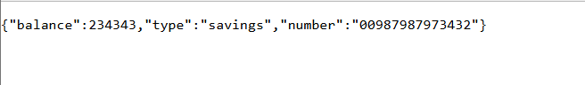

LOAN MICROSERVICE:

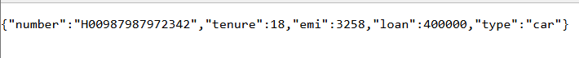

**ADDITIONAL EXERCISE:**

Create Eureka Discovery Server and register microservices

